Q1. From the provided dataset, classify the given feature vector using knn.
Calculate the distance using the Manhattan (p=1) or Minkowski distance formulas.
Euclidean distance = √(X₂-X₁)² + (Y₂-Y₁)² where p = 2 for Minkowski distance
BRIGHTNESS | SATURATION | CLASS
40 | 20 | Red
50 | 50 | Blue
60 | 90 | Blue
10 | 25 | Red
70 | 70 | Blue
60 | 10 | Red
25 | 80 | Blue

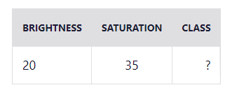
d1 = √(20 - 40)² + (35 - 20)²
= √400 + 225
= √625
= 25
BRIGHTNESS | SATURATION | CLASS | DISTANCE
40 | 20 | Red | 25
50 | 50 | Blue | 33.54
60 | 90 | Blue | 68.01
10 | 25 | Red | 10
70 | 70 | Blue | 61.03
60 | 10 | Red | 47.17
25 | 80 | Blue | 45

Let's rearrange the distances in ascending order:
BRIGHTNESS | SATURATION | CLASS | DISTANCE
10 | 25 | Red | 10
40 | 20 | Red | 25
50 | 50 | Blue | 33.54
25 | 80 | Blue | 45
60 | 10 | Red | 47.17
70 | 70 | Blue | 61.03
60 | 90 | Blue | 68.01

K | CLASS
1 | Red
2 | Red
3 | Red
4 | -
5 | Red

Q2.
Initial perceptron rule is fairly simple and can be summarized by the following steps:
- Initialize the weights to 0 or small random numbers.
- For each training sample xⁱ: calculate the output value and update the weights.
- The output value is the class label predicted by the unit step function that we defined earlier and the weight update can be written more formally as wⱼ₊₁ = wⱼ + Δwⱼ.
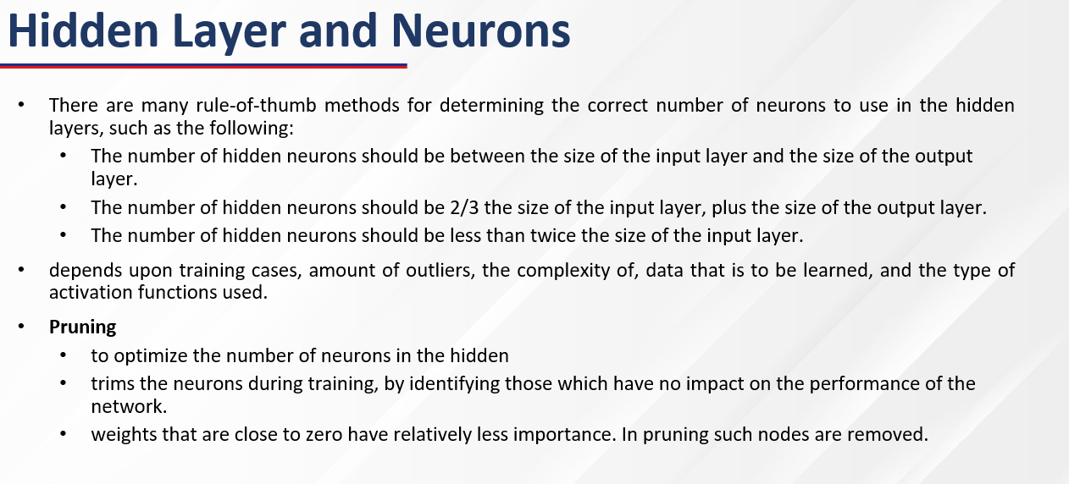
- The value for updating the weights at each increment is calculated by the learning rule: Δwⱼ = η(targetⁱ − outputⁱ) xⱼⁱ
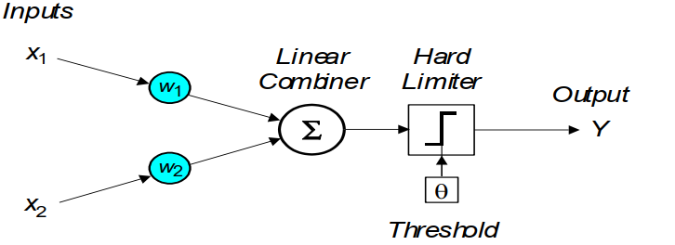

How to start to create model from provided dataset:
- Dimensionality Reduction
  - PCA
  - RFE
- Performance Estimation and Evaluation
  - Statistical Analysis
  - CV techniques with performance analysis

